ASSIGNMENT – 7

Summarizing data with Aggregate Functions

Q1) Write a query that counts all orders for October 3 .

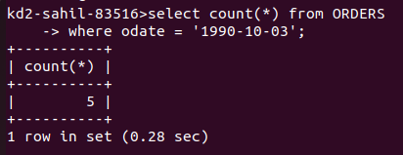

Q2) write a query that counts the numbers of a different non-NULL city values in the Customer's table.
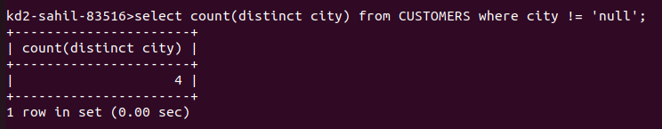

Q3) Write a query that selects each customers smallest order.
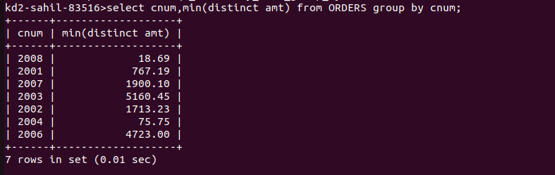

Q4) write a query that selects the first customers, in alphabetical order, whose name
begins with G.

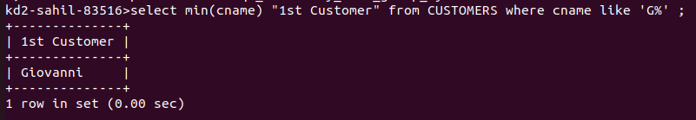

Q5) write a query that selects the highest rating in each city.

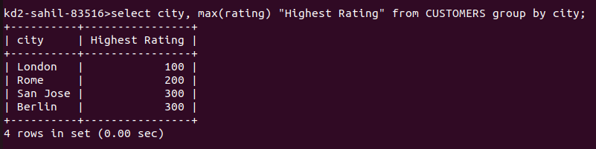

Q6) write a query that counts the number of salespeople registering orders for each day. (If a salesperson has more than one order on a givenday, he or she should be counted only once.)

